**SQL Handbook with Real-Time Examples**

**Table of Contents**

1. Introduction to SQL
   * What is SQL?
   * Importance of SQL
2. SQL Basics
   * SQL Syntax
   * SQL Data Types
3. SQL Commands
   * Data Definition Language (DDL)
     + CREATE
     + ALTER
     + DROP
   * Data Manipulation Language (DML)
     + SELECT
     + INSERT
     + UPDATE
     + DELETE
   * Data Control Language (DCL)
     + GRANT
     + REVOKE
   * Transaction Control Language (TCL)
     + COMMIT
     + ROLLBACK
     + SAVEPOINT
4. SQL Functions
   * Aggregate Functions
   * Scalar Functions
5. SQL Joins
   * INNER JOIN
   * LEFT JOIN
   * RIGHT JOIN
   * FULL JOIN
6. SQL Clauses
   * WHERE
   * ORDER BY
   * GROUP BY
   * HAVING
7. Advanced SQL
   * Subqueries
   * Indexes
   * Views
   * Stored Procedures
   * Triggers
   * Window Functions
   * Common Table Expressions (CTEs)
8. SQL Best Practices
   * Writing Efficient SQL Queries
   * Security Considerations
   * Common Pitfalls and How to Avoid Them

**1. Introduction to SQL**

**What is SQL?**

SQL (Structured Query Language) is a standard programming language specifically designed for managing and manipulating relational databases. It allows users to create, read, update, and delete data within a database.

**Importance of SQL**

SQL is essential for data management and is widely used in various applications, from small-scale to enterprise-level databases. Its ability to handle large datasets and perform complex queries makes it a critical skill for database administrators, data analysts, and developers.

## 2. SQL Basics

### SQL Syntax

SQL statements are composed of clauses, expressions, and predicates. Each SQL statement ends with a semicolon (;).

Example:

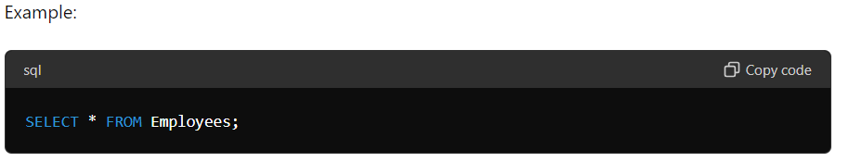

### SQL Data Types

Common SQL data types include:

* INT (integer)
* VARCHAR (variable-length character string)
* CHAR (fixed-length character string)
* DATE (date value)
* BOOLEAN (true/false value)
* FLOAT (floating point number)

## 3. SQL Commands

### Data Definition Language (DDL)

DDL commands define and manage database structures.

#### CREATE

Creates a new table or database.

Example:

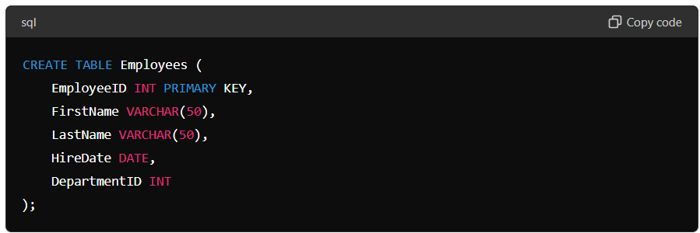

Explanation: This command creates a new table called **Employees** with columns for employee ID, first name, last name, hire date, and department ID.

#### ALTER

Modifies an existing database object, such as a table.

Example:

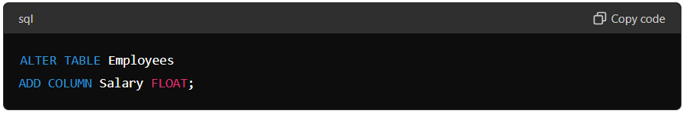

Explanation: This command adds a new column called Salary to the Employees table.

#### DROP

Deletes an existing database object.

Example:

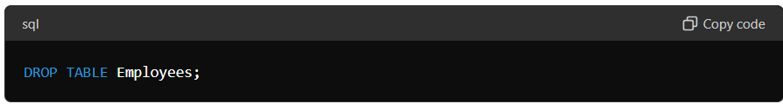

Explanation: This command deletes the Employees table from the database.

### Data Manipulation Language (DML)

DML commands manipulate data within database objects.

#### SELECT

Retrieves data from a database.

Example:

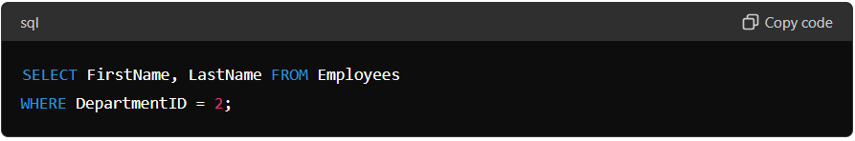

Explanation: This command retrieves the first and last names of employees who work in department 2.

#### INSERT

Adds new records to a table.

Example:

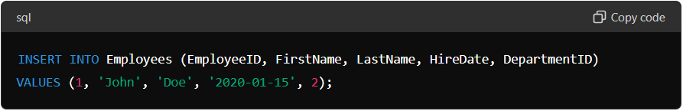

Explanation: This command adds a new employee with the specified details to the Employees table.

#### UPDATE

Modifies existing records in a table.

Example:

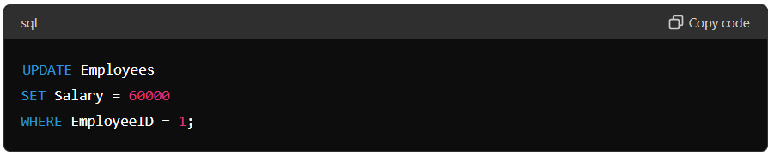

Explanation: This command updates the salary of the employee with ID 1 to 60000.

#### DELETE

Removes records from a table.

Example:

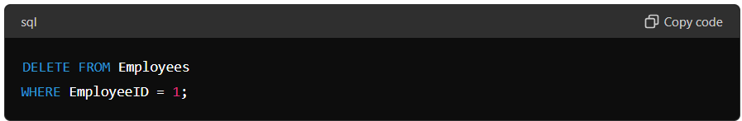

Explanation: This command removes the employee with ID 1 from the Employees table.

### 

### Data Control Language (DCL)

DCL commands control access to data.

#### GRANT

Gives user access privileges to the database.

Example:

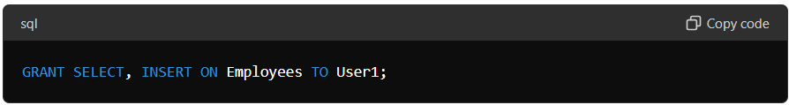

Explanation: This command grants the user User1 the ability to select and insert data into the Employees table.

#### REVOKE

Removes user access privileges.

Example:

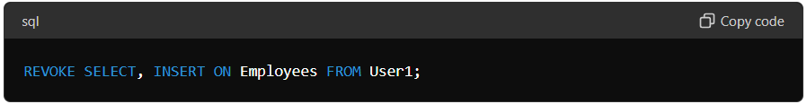

Explanation: This command removes the ability of User1 to select and insert data into the Employees table.

### Transaction Control Language (TCL)

TCL commands manage transactions in the database.

#### COMMIT

Saves the current transaction.

Example:

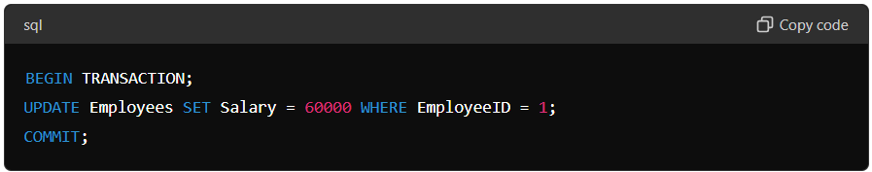

Explanation: This command starts a transaction, updates the salary of employee 1, and then saves the changes.

#### ROLLBACK

Undoes the current transaction.

Example:

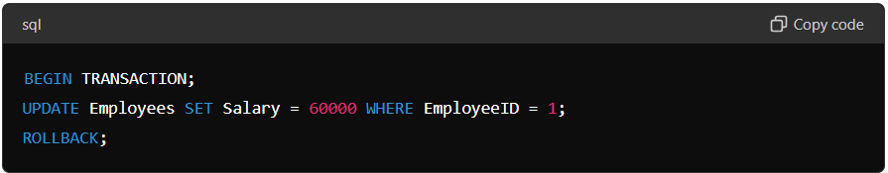

Explanation: This command starts a transaction, updates the salary of employee 1, but then undoes the change.

#### SAVEPOINT

Sets a savepoint within a transaction.

Example:

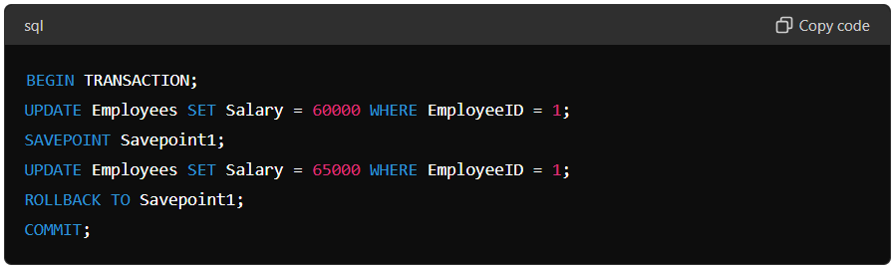

Explanation: This command sets a savepoint after the first update, rolls back to that savepoint after the second update, and then saves the changes.

**4. SQL Functions**

**Aggregate Functions**

Perform calculations on multiple values to return a single value.

* AVG(): Returns the average value.
* COUNT(): Returns the number of rows.
* MAX(): Returns the maximum value.
* MIN(): Returns the minimum value.
* SUM(): Returns the total sum.

Example:

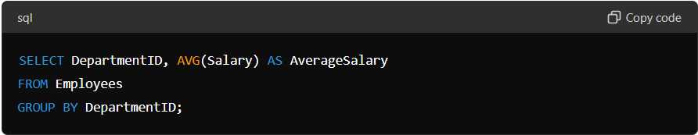

Explanation: This command calculates the average salary for each department.

**Scalar Functions**

Return a single value based on input values.

* UCASE(): Converts a field to uppercase.
* LCASE(): Converts a field to lowercase.
* LEN(): Returns the length of a field.
* ROUND(): Rounds a numeric field to the number of decimals specified.
* NOW(): Returns the current date and time.

Example:

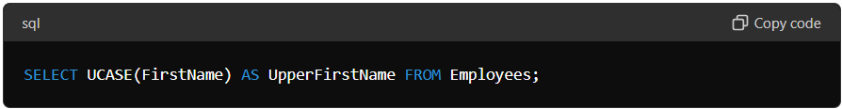

Explanation: This command converts the first names of employees to uppercase.

## 5. SQL Joins

### INNER JOIN

Returns records that have matching values in both tables.

Example:

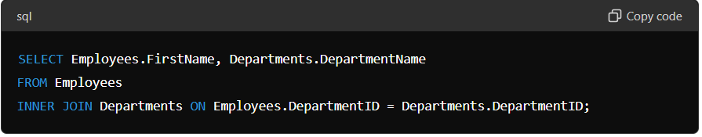

Explanation: This command retrieves the first names of employees along with their department names where there is a match.

### LEFT JOIN

Returns all records from the left table and matched records from the right table.

Example:

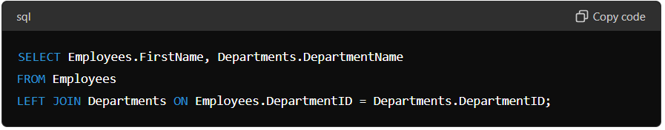

Explanation: This command retrieves the first names of employees and their department names, showing all employees even if they are not assigned to a department.

### RIGHT JOIN

Returns all records from the right table and matched records from the left table.

Example:

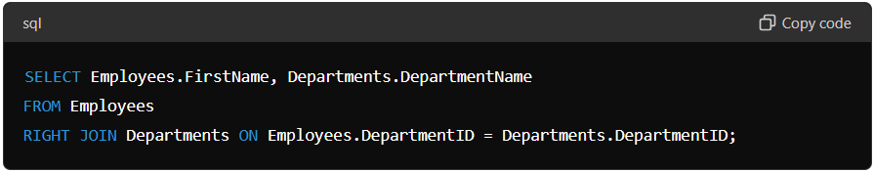

Explanation: This command retrieves the first names of employees and their department names, showing all departments even if they have no employees.

### FULL JOIN

Returns all records when there is a match in either left or right table.

Example:

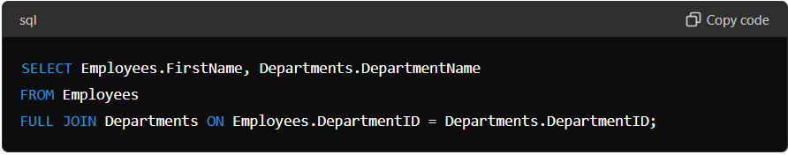

Explanation: This command retrieves the first names of employees and their department names, showing all employees and all departments.

## 6. SQL Clauses

### WHERE

Filters records based on a specified condition.

Example:

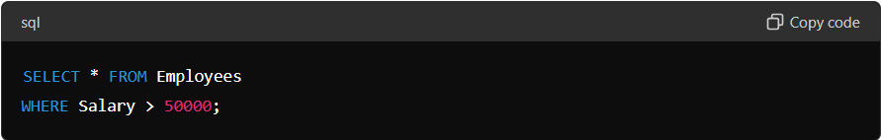

Explanation: This command retrieves all employees with a salary greater than 50000.

### ORDER BY

Sorts the result set in ascending or descending order.

Example:

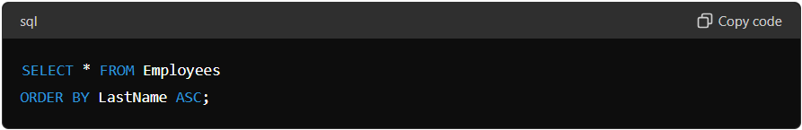

Explanation: This command retrieves all employees sorted by last name in ascending order.

### GROUP BY

Groups rows that have the same values into summary rows.

Example:

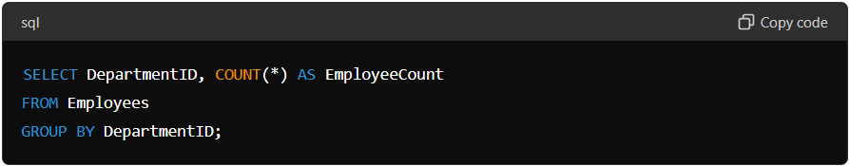

Explanation: This command groups employees by department ID and counts the number of employees in each department.

### HAVING

Filters groups based on a specified condition.

Example:

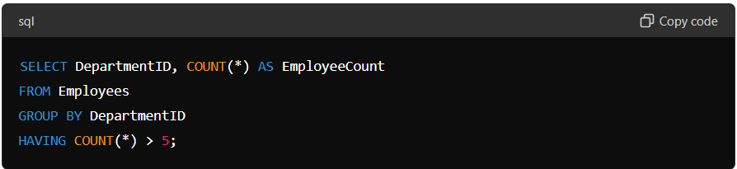

Explanation: This command filters the groups to only include departments with more than 5 employees.

## 7. Advanced SQL

### Subqueries

A query within another query.

Example:

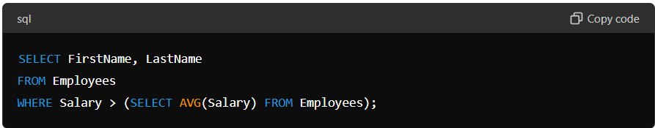

Explanation: This command retrieves the first and last names of employees whose salary is higher than the average salary of all employees.

### Indexes

Improve the speed of data retrieval.

Example:

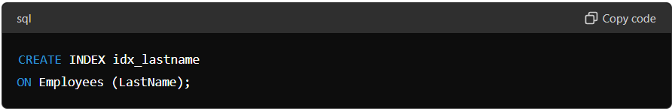

Explanation: This command creates an index on the LastName column of the Employees table to speed up searches by last name.

### Views

A virtual table based on the result set of an SQL statement.

Example:

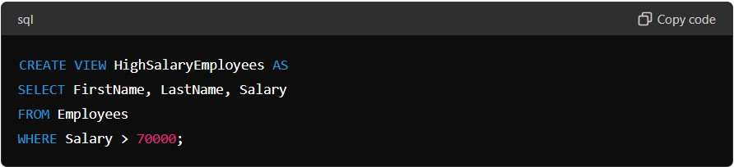

Explanation: This command creates a virtual table called HighSalaryEmployees that contains employees with a salary greater than 70000.

### Stored Procedures

A set of SQL statements with an assigned name that can be executed.

Example:

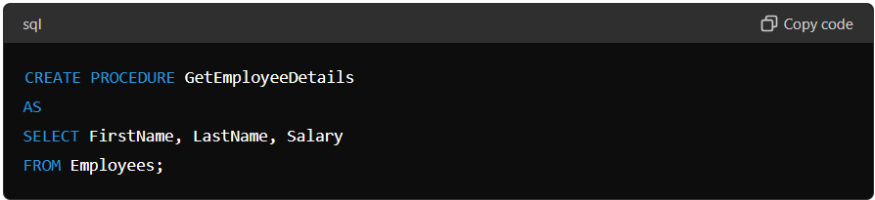

Explanation: This command creates a stored procedure called GetEmployeeDetails that retrieves the first names, last names, and salaries of employees when executed.

### Triggers

Automatically execute a specified set of SQL statements when a certain event occurs in the database.

Example:

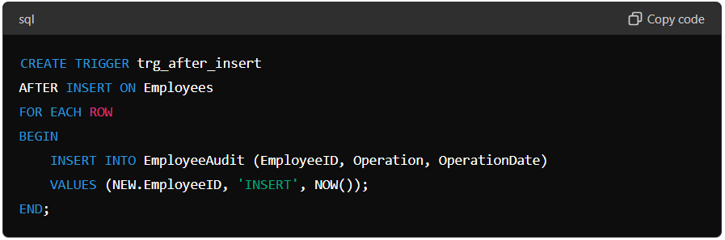

Explanation: This command creates a trigger that automatically inserts a record into the EmployeeAudit table every time a new record is added to the Employees table.

### Window Functions

Perform calculations across a set of table rows related to the current row.

Example:

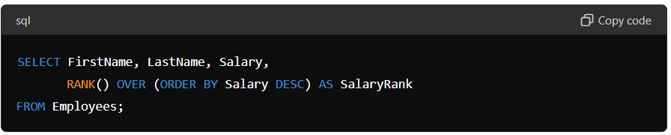

Explanation: This command assigns a rank to each employee based on their salary, with the highest salary getting rank 1.

### Common Table Expressions (CTEs)

A temporary result set that can be referenced within a SELECT, INSERT, UPDATE, or DELETE statement.

Example:

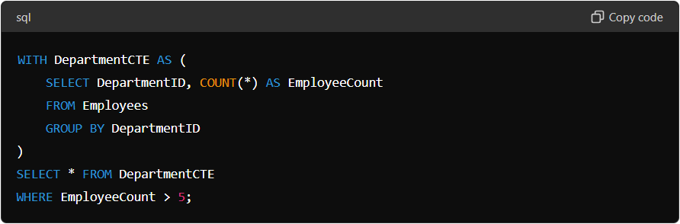

**\*\*\*\*\*\*\*\*\*\*\*\*\*\*\*\*\*\*\*\*\*\*\*\*\*\*\*Scenario\*\*\*\*\*\*\*\*\*\*\*\*\*\*\*\*\*\*\*\*\*\*\*\*\*\*\*\*\*\*\***

Sure! Let's create an example data pipeline for pharmaceutical sales data. This example will demonstrate extracting data from a raw sales table, transforming it by cleaning, aggregating, and enriching it, and then loading it into a final table ready for analysis.

We have the following tables:

* raw_sales: This contains raw sales data.
* drug_details: This contains details about each drug.
* cleaned_sales: This will store cleaned and processed sales data.
* final_sales: This will store the final enriched sales data ready for analysis.

**Raw Sales Table (raw_sales)**

Columns:

* sale_id: Unique identifier for each sale.
* drug_id: Identifier for the drug sold.
* quantity: Quantity of the drug sold.
* sale_date: Date of the sale.
* price: Price of the sale.
* customer_id: Identifier for the customer.

**Drug Details Table (drug_details)**

Columns:

* drug_id: Identifier for the drug.
* drug_name: Name of the drug.
* category: Category of the drug.

**Step-by-Step ETL Process**

1. **Extract**: Extract data from the raw_sales table.
2. **Transform**:
   * Clean data: Remove records with null values or invalid data.
   * Aggregate data: Calculate total sales and quantities.
   * Enrich data: Join with drug_details to get drug names and categories.
3. **Load**: Load the transformed data into the final_sales table.

**SQL Code :**

Here is the complete SQL script to run the entire ETL process:

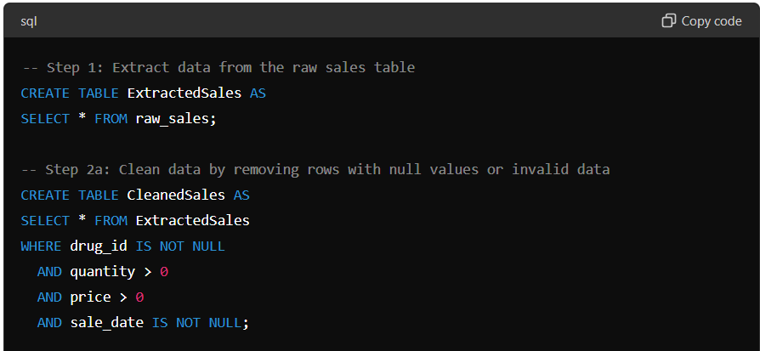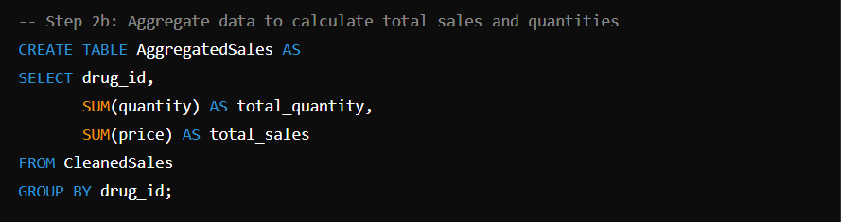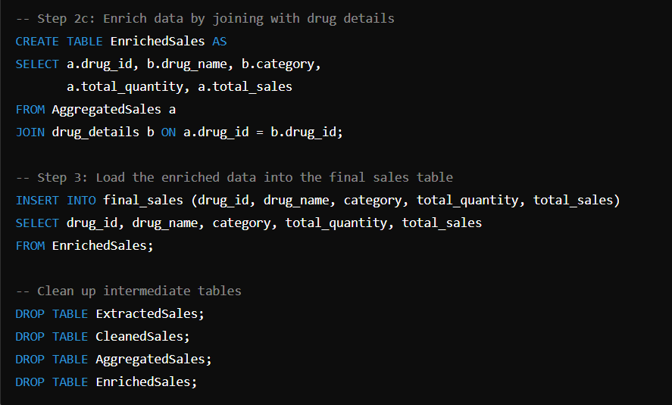

**Explanation**

1. **Extract**: Data is extracted from the raw_sales table and stored in ExtractedSales.
2. **Transform**:
   * **Clean**: The data is cleaned by removing records with null or invalid values and stored in CleanedSales.
   * **Aggregate**: The cleaned data is aggregated to calculate total sales and quantities for each drug and stored in AggregatedSales.
   * **Enrich**: The aggregated data is enriched by joining it with the drug_details table to include drug names and categories and stored in EnrichedSales.
3. **Load**: The enriched data is inserted into the final_sales table.
4. **Cleanup**: Intermediate tables are dropped to free up space.

Give me 10 complex query questions based on industry standards with answers.

ChatGPT

Sure, I can provide some complex SQL query questions along with their answers. These queries cover a range of topics that are commonly encountered in the data analytics industry.

1. **Question:** Find the top three products by sales in each year.

sql

Copy code

SELECT year, product_id, total_sales

FROM (

SELECT year, product_id, total_sales,

RANK() OVER (PARTITION BY year ORDER BY total_sales DESC) as rank

FROM sales

) ranked_sales

WHERE rank <= 3;

1. **Question:** Retrieve the departments with average salaries above the company's average salary.

sql

Copy code

SELECT department_id, AVG(salary) as avg_salary

FROM employees

GROUP BY department_id

HAVING AVG(salary) > (SELECT AVG(salary) FROM employees);

1. **Question:** Find the cumulative sales per month.

sql

Copy code

SELECT month, SUM(total_sales) OVER (ORDER BY month) as cumulative_sales

FROM sales;

1. **Question:** List employees who have more than one manager.

sql

Copy code

SELECT employee_id

4o

Suppose that you are data analyst in pharmaceutical industry, help me with the practical SQL examples with answers which I will be using in pharma industry in my job rule

ChatGPT

Sure! Here are ten practical SQL query examples tailored for a data analyst in the pharmaceutical industry. These examples cover a range of tasks you might encounter, such as analyzing drug sales, patient data, clinical trials, and supply chain management.

1. **Question:** Find the total sales of each drug for the current year.

sql

Copy code

SELECT drug_name, SUM(sales_amount) as total_sales

FROM drug_sales

WHERE YEAR(sale_date) = YEAR(CURRENT_DATE)

GROUP BY drug_name;

1. **Question:** Identify the top 5 drugs by sales revenue in each region.

sql

Copy code

SELECT region, drug_name, total_sales

FROM (

SELECT region, drug_name, SUM(sales_amount) as total_sales,

RANK() OVER (PARTITION BY region ORDER BY SUM(sales_amount) DESC) as rank

FROM drug_sales

GROUP BY region, drug_name

) ranked_sales

WHERE rank <= 5;

1. **Question:** Calculate the average age of patients participating in clinical trials for a specific drug.

sql

Copy code

SELECT drug_name, AVG(patient_age) as average_age

FROM clinical_trials

WHERE drug_name = 'Drug_X'

GROUP BY drug_name;

1. **Question:** List the drugs that have not been sold in the past 6 months.

sql

Copy code

SELECT drug_name

FROM drugs

WHERE drug_name NOT IN (

SELECT DISTINCT drug_name

FROM drug_sales

WHERE sale_date >= DATEADD(MONTH, -6, CURRENT_DATE)

);

1. **Question:** Find the total number of patients treated by each doctor in the past year.

sql

Copy code

SELECT doctor_id, COUNT(DISTINCT patient_id) as patient_count

FROM treatments

WHERE treatment_date >= DATEADD(YEAR, -1, CURRENT_DATE)

GROUP BY doctor_id;

1. **Question:** Identify the regions with the highest increase in drug sales compared to the previous year.

sql

Copy code

WITH sales_current_year AS (

SELECT region, SUM(sales_amount) as total_sales

FROM drug_sales

WHERE YEAR(sale_date) = YEAR(CURRENT_DATE)

GROUP BY region

),

sales_previous_year AS (

SELECT region, SUM(sales_amount) as total_sales

FROM drug_sales

WHERE YEAR(sale_date) = YEAR(CURRENT_DATE) - 1

GROUP BY region

)

SELECT c.region, c.total_sales - p.total_sales as sales_increase

FROM sales_current_year c

JOIN sales_previous_year p ON c.region = p.region

ORDER BY sales_increase DESC;

1. **Question:** Calculate the average duration of clinical trials for each drug.

sql

Copy code

SELECT drug_name, AVG(DATEDIFF(day, start_date, end_date)) as average_duration

FROM clinical_trials

GROUP BY drug_name;

1. **Question:** Find the most frequently prescribed drug in the last quarter.

sql

Copy code

SELECT drug_name, COUNT(*) as prescription_count

FROM prescriptions

WHERE prescription_date >= DATEADD(MONTH, -3, CURRENT_DATE)

GROUP BY drug_name

ORDER BY prescription_count DESC

LIMIT 1;

1. **Question:** Determine the distribution of patient age groups for a specific drug in clinical trials.

sql

Copy code

SELECT

CASE

WHEN patient_age < 18 THEN 'Under 18'

WHEN patient_age BETWEEN 18 AND 35 THEN '18-35'

WHEN patient_age BETWEEN 36 AND 50 THEN '36-50'

WHEN patient_age BETWEEN 51 AND 65 THEN '51-65'

ELSE 'Over 65'

END as age_group,

COUNT(*) as patient_count

FROM clinical_trials

WHERE drug_name = 'Drug_X'

GROUP BY age_group;

1. **Question:** List the suppliers who provided drugs that had zero sales in the past year.

sql

Copy code

SELECT supplier_id, supplier_name

FROM suppliers

WHERE supplier_id IN (

SELECT DISTINCT supplier_id

FROM drugs

WHERE drug_id NOT IN (

SELECT DISTINCT drug_id

FROM drug_sales

WHERE YEAR(sale_date) = YEAR(CURRENT_DATE) - 1

)

);

These queries should give you a good starting point for various data analysis tasks you might encounter in the pharmaceutical industry. Feel free to adjust them to fit your specific database schema and business needs.

4o

Help me with more complex SQL questions and answers as per the industry standards

ChatGPT

Certainly! Here are additional complex SQL questions and answers tailored to the pharmaceutical industry:

1. **Question:** Identify patients who have been prescribed a new drug (introduced in the last year) and check their treatment outcomes.

sql

Copy code

SELECT p.patient_id, p.name, t.drug_name, t.treatment_outcome

FROM patients p

JOIN treatments t ON p.patient_id = t.patient_id

JOIN drugs d ON t.drug_name = d.drug_name

WHERE d.introduction_date >= DATEADD(YEAR, -1, CURRENT_DATE);

1. **Question:** Calculate the retention rate of patients in a specific clinical trial.

sql

Copy code

WITH initial_patients AS (

SELECT trial_id, COUNT(DISTINCT patient_id) as initial_count

FROM clinical_trials

WHERE trial_id = 'Trial_X'

GROUP BY trial_id

),

final_patients AS (

SELECT trial_id, COUNT(DISTINCT patient_id) as final_count

FROM clinical_trial_results

WHERE trial_id = 'Trial_X'

AND result_date = (SELECT MAX(result_date) FROM clinical_trial_results WHERE trial_id = 'Trial_X')

GROUP BY trial_id

)

SELECT i.trial_id,

(f.final_count * 100.0 / i.initial_count) as retention_rate

FROM initial_patients i

JOIN final_patients f ON i.trial_id = f.trial_id;

1. **Question:** Find the drugs with the highest adverse reaction rates, considering only reactions reported within 30 days of the prescription.

sql

Copy code

WITH reactions_within_30_days AS (

SELECT drug_id, COUNT(*) as reaction_count

FROM adverse_reactions

WHERE DATEDIFF(day, prescription_date, reaction_date) <= 30

GROUP BY drug_id

),

total_prescriptions AS (

SELECT drug_id, COUNT(*) as prescription_count

FROM prescriptions

GROUP BY drug_id

)

SELECT r.drug_id,

(r.reaction_count * 100.0 / p.prescription_count) as adverse_reaction_rate

FROM reactions_within_30_days r

JOIN total_prescriptions p ON r.drug_id = p.drug_id

ORDER BY adverse_reaction_rate DESC;

1. **Question:** Determine the average time between the first prescription and the first adverse reaction for each drug.

sql

Copy code

WITH first_prescriptions AS (

SELECT patient_id, drug_id, MIN(prescription_date) as first_prescription_date

FROM prescriptions

GROUP BY patient_id, drug_id

),

first_reactions AS (

SELECT patient_id, drug_id, MIN(reaction_date) as first_reaction_date

FROM adverse_reactions

GROUP BY patient_id, drug_id

)

SELECT p.drug_id, AVG(DATEDIFF(day, p.first_prescription_date, r.first_reaction_date)) as avg_days_to_reaction

FROM first_prescriptions p

JOIN first_reactions r ON p.patient_id = r.patient_id AND p.drug_id = r.drug_id

GROUP BY p.drug_id;

1. **Question:** Identify the top 10 patients with the highest total cost of treatments over the last year.

sql

Copy code

SELECT patient_id, SUM(treatment_cost) as total_cost

FROM treatments

WHERE treatment_date >= DATEADD(YEAR, -1, CURRENT_DATE)

GROUP BY patient_id

ORDER BY total_cost DESC

LIMIT 10;

1. **Question:** Calculate the percentage of successful treatments for each drug over the past five years.

sql

Copy code

WITH total_treatments AS (

SELECT drug_name, COUNT(*) as total_treatments

FROM treatments

WHERE treatment_date >= DATEADD(YEAR, -5, CURRENT_DATE)

GROUP BY drug_name

),

successful_treatments AS (

SELECT drug_name, COUNT(*) as successful_treatments

FROM treatments

WHERE treatment_date >= DATEADD(YEAR, -5, CURRENT_DATE)

AND treatment_outcome = 'Successful'

GROUP BY drug_name

)

SELECT t.drug_name,

(s.successful_treatments * 100.0 / t.total_treatments) as success_rate

FROM total_treatments t

JOIN successful_treatments s ON t.drug_name = s.drug_name

ORDER BY success_rate DESC;

1. **Question:** Find the average number of follow-up visits per patient for a specific drug.

sql

Copy code

SELECT drug_name, AVG(follow_up_count) as avg_follow_ups

FROM (

SELECT patient_id, drug_name, COUNT(*) as follow_up_count

FROM follow_ups

WHERE drug_name = 'Drug_X'

GROUP BY patient_id, drug_name

) subquery

GROUP BY drug_name;

1. **Question:** Determine the total quantity of drugs supplied by each supplier over the past year.

sql

Copy code

SELECT supplier_id, SUM(quantity_supplied) as total_quantity

FROM drug_supplies

WHERE supply_date >= DATEADD(YEAR, -1, CURRENT_DATE)

GROUP BY supplier_id;

1. **Question:** Identify patients who have switched from one specific drug to another within 90 days.

sql

Copy code

SELECT p.patient_id, p.name, ps.old_drug_name, ps.new_drug_name

FROM patients p

JOIN (

SELECT patient_id, old_drug_name, new_drug_name, DATEDIFF(day, old_drug_date, new_drug_date) as switch_days

FROM (

SELECT patient_id,

LAG(drug_name) OVER (PARTITION BY patient_id ORDER BY prescription_date) as old_drug_name,

drug_name as new_drug_name,

LAG(prescription_date) OVER (PARTITION BY patient_id ORDER BY prescription_date) as old_drug_date,

prescription_date as new_drug_date

FROM prescriptions

) subquery

WHERE old_drug_name IS NOT NULL AND new_drug_name IS NOT NULL

AND switch_days <= 90

) ps ON p.patient_id = ps.patient_id;

1. **Question:** Calculate the inventory turnover ratio for each drug over the last year.

sql

Copy code

WITH annual_sales AS (

SELECT drug_id, SUM(quantity_sold) as total_sales

FROM drug_sales

WHERE sale_date >= DATEADD(YEAR, -1, CURRENT_DATE)

GROUP BY drug_id

),

average_inventory AS (

SELECT drug_id, AVG(inventory_quantity) as avg_inventory

FROM drug_inventory

WHERE inventory_date >= DATEADD(YEAR, -1, CURRENT_DATE)

GROUP BY drug_id

)

SELECT a.drug_id,

(a.total_sales * 1.0 / i.avg_inventory) as inventory_turnover_ratio

FROM annual_sales a

JOIN average_inventory i ON a.drug_id = i.drug_id

ORDER BY inventory_turnover_ratio DESC;

These queries are designed to address a variety of analytical needs within the pharmaceutical industry, providing insights into sales, patient outcomes, clinical trial efficacy, and supply chain performance. Adjust these queries to fit your specific data schema and business requirements.

4o

Also help me with the full advanced SQL topics and their examples suitable for pharma industry

ChatGPT

Certainly! Here are some advanced SQL topics along with practical examples suitable for the pharmaceutical industry:

**1. Window Functions**

**Window functions** allow you to perform calculations across a set of table rows related to the current row.

**Example: Calculate the moving average of sales for each drug over the last 6 months.**

sql

Copy code

SELECT drug_name, sale_date, sales_amount,

AVG(sales_amount) OVER (PARTITION BY drug_name ORDER BY sale_date ROWS BETWEEN 5 PRECEDING AND CURRENT ROW) as moving_avg_sales

FROM drug_sales;

**2. Common Table Expressions (CTEs)**

**CTEs** provide a way to break down complex queries and improve readability.

**Example: Find the total sales and the percentage growth in sales for each drug compared to the previous month.**

sql

Copy code

WITH monthly_sales AS (

SELECT drug_name, DATE_TRUNC('month', sale_date) as sale_month, SUM(sales_amount) as total_sales

FROM drug_sales

GROUP BY drug_name, sale_month

),

monthly_sales_with_lag AS (

SELECT drug_name, sale_month, total_sales,

LAG(total_sales) OVER (PARTITION BY drug_name ORDER BY sale_month) as prev_month_sales

FROM monthly_sales

)

SELECT drug_name, sale_month, total_sales,

(total_sales - prev_month_sales) * 100.0 / prev_month_sales as percentage_growth

FROM monthly_sales_with_lag

WHERE prev_month_sales IS NOT NULL;

**3. Recursive CTEs**

**Recursive CTEs** are useful for hierarchical data and self-referencing relationships.

**Example: Identify the drug supply chain hierarchy and calculate the total supply cost.**

sql

Copy code

WITH RECURSIVE supply_chain AS (

SELECT supplier_id, drug_id, cost, 1 as level

FROM drug_supplies

WHERE supplier_id = 'Supplier_1'

UNION ALL

SELECT ds.supplier_id, ds.drug_id, ds.cost, sc.level + 1

FROM drug_supplies ds

JOIN supply_chain sc ON ds.supplier_id = sc.drug_id

)

SELECT supplier_id, drug_id, SUM(cost) as total_cost

FROM supply_chain

GROUP BY supplier_id, drug_id;

**4. PIVOT and UNPIVOT**

**PIVOT** and **UNPIVOT** operations allow you to transform rows into columns and vice versa.

**Example: Pivot monthly sales data to show each month's sales as columns.**

sql

Copy code

SELECT *

FROM (

SELECT drug_name, DATE_TRUNC('month', sale_date) as sale_month, sales_amount

FROM drug_sales

) sales_data

PIVOT (

SUM(sales_amount)

FOR sale_month IN ('2024-01' AS Jan, '2024-02' AS Feb, '2024-03' AS Mar)

) pivot_table;

**5. Analytical Functions**

Analytical functions provide insights such as ranking, distribution, and cumulative calculations.

**Example: Rank drugs based on their sales within each region and calculate the cumulative sales.**

sql

Copy code

SELECT region, drug_name, sales_amount,

RANK() OVER (PARTITION BY region ORDER BY sales_amount DESC) as sales_rank,

SUM(sales_amount) OVER (PARTITION BY region ORDER BY sales_amount DESC) as cumulative_sales

FROM drug_sales;

**6. JSON Functions**

With the growing use of semi-structured data, handling JSON in SQL is essential.

**Example: Extract and aggregate information from JSON-formatted patient records.**

sql

Copy code

SELECT patient_id,

JSON_VALUE(patient_data, '$.age') as age,

JSON_VALUE(patient_data, '$.treatments[0].drug_name') as first_treatment_drug

FROM patients

WHERE JSON_VALUE(patient_data, '$.condition') = 'Condition_X';

**7. Full-Text Search**

**Full-text search** allows for efficient querying of text data, which is crucial for searching through medical records or research papers.

**Example: Find clinical trial reports that mention a specific adverse reaction.**

sql

Copy code

SELECT report_id, report_content

FROM clinical_trial_reports

WHERE CONTAINS(report_content, 'adverse reaction');

**8. Temporal Tables**

**Temporal tables** allow for versioning of table data, enabling you to track changes over time.

**Example: Retrieve the state of the drug inventory as of a specific date.**

sql

Copy code

SELECT drug_id, quantity

FROM drug_inventory FOR SYSTEM_TIME AS OF '2024-01-01';

**9. Indexing and Performance Tuning**

Optimizing query performance through appropriate indexing and analyzing execution

4o

Also help me with the full advanced SQL topics and their examples suitable for pharma industry

ChatGPT

Absolutely! Here’s a detailed breakdown of advanced SQL topics with examples that are particularly relevant for the pharmaceutical industry:

**1. Window Functions**

Window functions allow you to perform calculations across a set of table rows that are somehow related to the current row.

**Example: Calculate the moving average of drug sales over the last 6 months for each drug.**

sql

Copy code

SELECT

drug_name,

sale_date,

sales_amount,

AVG(sales_amount) OVER (PARTITION BY drug_name ORDER BY sale_date ROWS BETWEEN 5 PRECEDING AND CURRENT ROW) AS moving_avg_sales

FROM

drug_sales;

**2. Common Table Expressions (CTEs)**

CTEs make complex queries more readable and manageable.

**Example: Calculate the year-over-year growth in sales for each drug.**

sql

Copy code

WITH yearly_sales AS (

SELECT

drug_name,

YEAR(sale_date) AS sale_year,

SUM(sales_amount) AS total_sales

FROM

drug_sales

GROUP BY

drug_name,

YEAR(sale_date)

)

SELECT

drug_name,

sale_year,

total_sales,

LAG(total_sales) OVER (PARTITION BY drug_name ORDER BY sale_year) AS prev_year_sales,

(total_sales - LAG(total_sales) OVER (PARTITION BY drug_name ORDER BY sale_year)) / NULLIF(LAG(total_sales) OVER (PARTITION BY drug_name ORDER BY sale_year), 0) * 100 AS yoy_growth

FROM

yearly_sales;

**3. Recursive CTEs**

Recursive CTEs are useful for hierarchical data and performing operations like traversing a supply chain.

**Example: Calculate the total supply cost for a hierarchical supply chain.**

sql

Copy code

WITH RECURSIVE supply_chain AS (

SELECT

supplier_id,

drug_id,

cost,

1 AS level

FROM

drug_supplies

WHERE

supplier_id = 'Supplier_1'

UNION ALL

SELECT

ds.supplier_id,

ds.drug_id,

ds.cost,

sc.level + 1

FROM

drug_supplies ds

JOIN

supply_chain sc ON ds.supplier_id = sc.drug_id

)

SELECT

supplier_id,

drug_id,

SUM(cost) AS total_cost

FROM

supply_chain

GROUP BY

supplier_id,

drug_id;

**4. PIVOT and UNPIVOT**

PIVOT and UNPIVOT transform rows into columns and vice versa.

**Example: Pivot monthly sales data to show each month’s sales as columns.**

sql

Copy code

SELECT

drug_name,

Jan,

Feb,

Mar

FROM (

SELECT

drug_name,

TO_CHAR(sale_date, 'Mon') AS sale_month,

sales_amount

FROM

drug_sales

) sales_data

PIVOT (

SUM(sales_amount) FOR sale_month IN ('Jan' AS Jan, 'Feb' AS Feb, 'Mar' AS Mar)

) pivot_table;

**5. Analytical Functions**

Analytical functions like RANK, DENSE_RANK, NTILE, etc., help to perform sophisticated data analysis.

**Example: Rank drugs by sales within each region and calculate cumulative sales.**

sql

Copy code

SELECT

region,

drug_name,

sales_amount,

RANK() OVER (PARTITION BY region ORDER BY sales_amount DESC) AS sales_rank,

SUM(sales_amount) OVER (PARTITION BY region ORDER BY sales_amount DESC) AS cumulative_sales

FROM

drug_sales;

**6. JSON Functions**

Working with JSON data is increasingly common, and SQL provides functions to handle JSON data.

**Example: Extract information from JSON-formatted patient records.**

sql

Copy code

SELECT

patient_id,

JSON_VALUE(patient_data, '$.age') AS age,

JSON_VALUE(patient_data, '$.treatments[0].drug_name') AS first_treatment_drug

FROM

patients

WHERE

JSON_VALUE(patient_data, '$.condition') = 'Condition_X';

**7. Full-Text Search**

Full-text search capabilities are important for searching large volumes of text data, such as clinical trial reports.

**Example: Find clinical trial reports that mention a specific adverse reaction.**

sql

Copy code

SELECT

report_id,

report_content

FROM

clinical_trial_reports

WHERE

CONTAINS(report_content, 'adverse reaction');

**8. Temporal Tables**

Temporal tables allow you to track changes to your data over time.

**Example: Retrieve the state of the drug inventory as of a specific date.**

sql

Copy code

SELECT

drug_id,

quantity

FROM

drug_inventory FOR SYSTEM_TIME AS OF '2024-01-01';

**9. Indexing and Performance Tuning**

Effective indexing and performance tuning ensure that your queries run efficiently.

**Example: Analyze query performance and create indexes to optimize frequently run queries.**

sql

Copy code

-- Analyze query performance

EXPLAIN ANALYZE

SELECT

drug_name,

SUM(sales_amount)

FROM

drug_sales

GROUP BY

drug_name;

-- Create an index to optimize the above query

CREATE INDEX idx_drug_sales_drug_name ON drug_sales (drug_name);

**10. Data Encryption and Security**

Ensuring data security is critical, especially in the pharmaceutical industry where sensitive data is handled.

**Example: Encrypt sensitive patient data.**

sql

Copy code

-- Encrypt data using a specific encryption algorithm

UPDATE

patients

SET

ssn = ENCRYPT(ssn, 'my_secret_key', 'aes')

WHERE

patient_id = 123;

-- Decrypt data when needed

SELECT

DECRYPT(ssn, 'my_secret_key', 'aes') AS decrypted_ssn

FROM

patients

WHERE

patient_id = 123;

**11. Machine Learning Integration**

SQL can be integrated with machine learning models for predictive analytics.

**Example: Use SQL to prepare data for machine learning models.**

sql

Copy code

SELECT

p.patient_id,

p.age,

p.gender,

d.drug_name,

t.treatment_outcome

FROM

patients p

JOIN

treatments t ON p.patient_id = t.patient_id

JOIN

drugs d ON t.drug_id = d.drug_id

WHERE

t.treatment_date >= DATEADD(YEAR, -5, CURRENT_DATE);

**12. Advanced Aggregations**

Advanced aggregations provide deeper insights by combining multiple metrics.

**Example: Calculate the average, median, and mode of drug prices.**

sql

Copy code

-- Calculate average price

SELECT

drug_name,

AVG(price) AS avg_price

FROM

drug_prices

GROUP BY

drug_name;

-- Calculate median price

WITH ranked_prices AS (

SELECT

drug_name,

price,

ROW_NUMBER() OVER (PARTITION BY drug_name ORDER BY price) AS row_num,

COUNT(*) OVER (PARTITION BY drug_name) AS total_count

FROM

drug_prices

)

SELECT

drug_name,

AVG(price) AS median_price

FROM

ranked_prices

WHERE

row_num IN ((total_count + 1) / 2, (total_count + 2) / 2)

GROUP BY

drug_name;

-- Calculate mode price

SELECT

drug_name,

price AS mode_price

FROM

(SELECT

drug_name,

price,

COUNT(*) AS price_count,

RANK() OVER (PARTITION BY drug_name ORDER BY COUNT(*) DESC) AS rank

FROM

drug_prices

GROUP BY

drug_name,

price

) ranked_prices

WHERE

rank = 1;

These advanced SQL topics and examples should equip you with powerful tools for data analysis, reporting, and performance optimization in the pharmaceutical industry. Adjust the examples as needed to fit your specific database schema and business requirements.

4o

Statics for data analysis, intermediate role

ChatGPT

For a data analyst in an intermediate role, especially in the pharmaceutical industry, understanding and applying statistical concepts is crucial. Below are key statistical topics and techniques, along with examples to illustrate their application in data analysis.

**1. Descriptive Statistics**

Descriptive statistics summarize and describe the main features of a dataset.

**Example: Calculate the mean, median, and standard deviation of drug sales.**

sql

Copy code

SELECT

drug_name,

AVG(sales_amount) AS mean_sales,

MEDIAN(sales_amount) AS median_sales,

STDDEV(sales_amount) AS stddev_sales

FROM

drug_sales

GROUP BY

drug_name;

**2. Hypothesis Testing**

Hypothesis testing helps to determine if there is a significant effect or difference in the data.

**Example: Test if there is a significant difference in average sales between two drugs.**

sql

Copy code

WITH sales_data AS (

SELECT

drug_name,

sales_amount

FROM

drug_sales

WHERE

drug_name IN ('Drug_A', 'Drug_B')

)

SELECT

drug_name,

sales_amount

INTO

sales_data_temp

FROM

sales_data;

-- Conduct a t-test (assuming you have access to a statistical library or can use an external tool)

**3. Correlation Analysis**

Correlation analysis measures the relationship between two variables.

**Example: Find the correlation between drug sales and marketing spend.**

sql

Copy code

SELECT

CORR(sales_amount, marketing_spend) AS correlation

FROM

drug_sales ds

JOIN

marketing_spend ms ON ds.drug_id = ms.drug_id;

**4. Regression Analysis**

Regression analysis estimates the relationships among variables.

**Example: Perform a simple linear regression to predict sales based on marketing spend.**

sql

Copy code

-- Assuming the use of a statistical package or external tool for detailed regression analysis

-- Basic SQL to extract data for regression

SELECT

sales_amount,

marketing_spend

FROM

drug_sales ds

JOIN

marketing_spend ms ON ds.drug_id = ms.drug_id;

**5. ANOVA (Analysis of Variance)**

ANOVA tests if there are significant differences between the means of three or more groups.

**Example: Perform ANOVA to compare the sales of multiple drugs.**

sql

Copy code

WITH sales_data AS (

SELECT

drug_name,

sales_amount

FROM

drug_sales

WHERE

drug_name IN ('Drug_A', 'Drug_B', 'Drug_C')

)

SELECT

drug_name,

sales_amount

INTO

sales_data_temp

FROM

sales_data;

-- Perform ANOVA using a statistical package or external tool

**6. Chi-Square Test**

The Chi-Square test assesses relationships between categorical variables.

**Example: Test if there is an association between adverse reactions and patient gender.**

sql

Copy code

SELECT

patient_gender,

adverse_reaction,

COUNT(*) AS count

FROM

patient_data

GROUP BY

patient_gender,

adverse_reaction;

-- Perform Chi-Square test using a statistical package or external tool

**7. Time Series Analysis**

Time series analysis examines data points collected or recorded at specific time intervals.

**Example: Analyze monthly sales trends and forecast future sales.**

sql

Copy code

SELECT

DATE_TRUNC('month', sale_date) AS sale_month,

SUM(sales_amount) AS total_sales

FROM

drug_sales

GROUP BY

sale_month

ORDER BY

sale_month;

-- Use a time series forecasting tool or library for detailed analysis

**8. Data Visualization**

Visualizing data helps in understanding trends, patterns, and outliers.

**Example: Create visualizations to show sales trends, distributions, and correlations.**

sql

Copy code

-- Example of SQL to extract data for visualization

SELECT

DATE_TRUNC('month', sale_date) AS sale_month,

SUM(sales_amount) AS total_sales

FROM

drug_sales

GROUP BY

sale_month

ORDER BY

sale_month;

-- Use visualization tools like Tableau, Power BI, or Matplotlib (Python) for creating charts

**9. Principal Component Analysis (PCA)**

PCA reduces the dimensionality of large datasets, improving interpretability while minimizing information loss.

**Example: Apply PCA to reduce the dimensionality of clinical trial data with multiple features.**

sql

Copy code

-- SQL to extract features for PCA analysis

SELECT

feature1,

feature2,

feature3,

feature4

FROM

clinical_trial_data;

-- Perform PCA using a statistical package or external tool

**10. Clustering**

Clustering groups similar data points together, often used in market segmentation.

**Example: Cluster patients based on treatment patterns and outcomes.**

sql

Copy code

-- SQL to extract patient data for clustering

SELECT

patient_id,

treatment1,

treatment2,

treatment3,

outcome

FROM

patient_treatments;

-- Perform clustering using a statistical package or external tool

**Tools and Libraries for Statistical Analysis**

1. **R**: A programming language and software environment for statistical computing and graphics.
2. **Python (pandas, numpy, scipy, statsmodels)**: Libraries for data manipulation, analysis, and visualization.
3. **SQL with Extensions**: Some SQL databases offer statistical extensions (e.g., PostgreSQL with PL/R, PL/Python).
4. **Excel**: Basic statistical analysis and data visualization